CSA1006 :-SOFTWARE ENGINEERING WITH UML

Name: MD. Fayaaz Ahmed

Reg.no: 192111226

1Q. Draw a USE-CASE diagram for Online Voting System using CASE tools

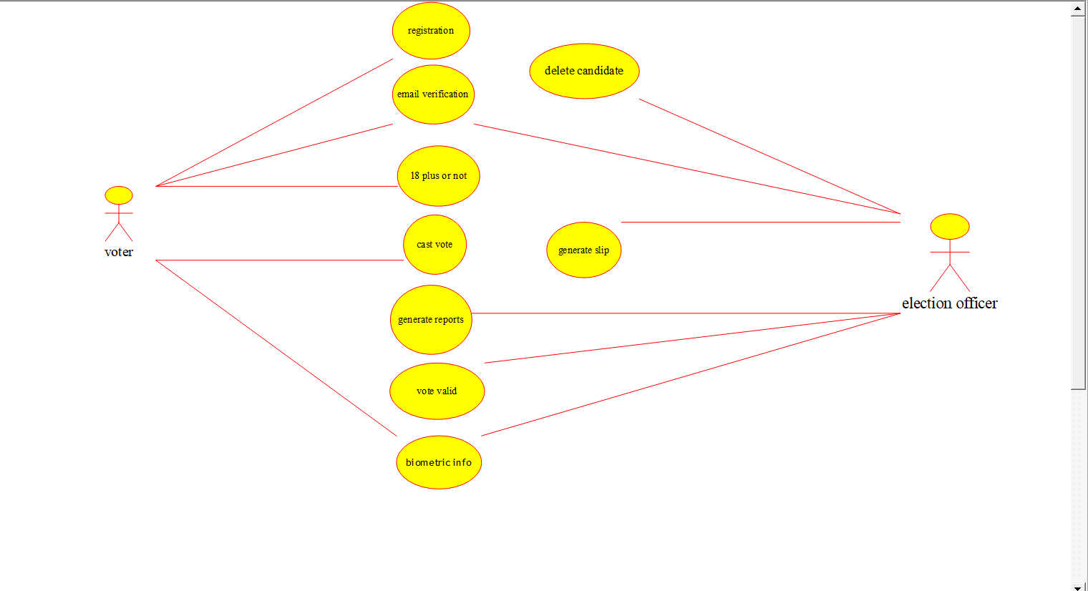

2Q. Draw a USE-CASE diagram for Library Management System using CASE tools.

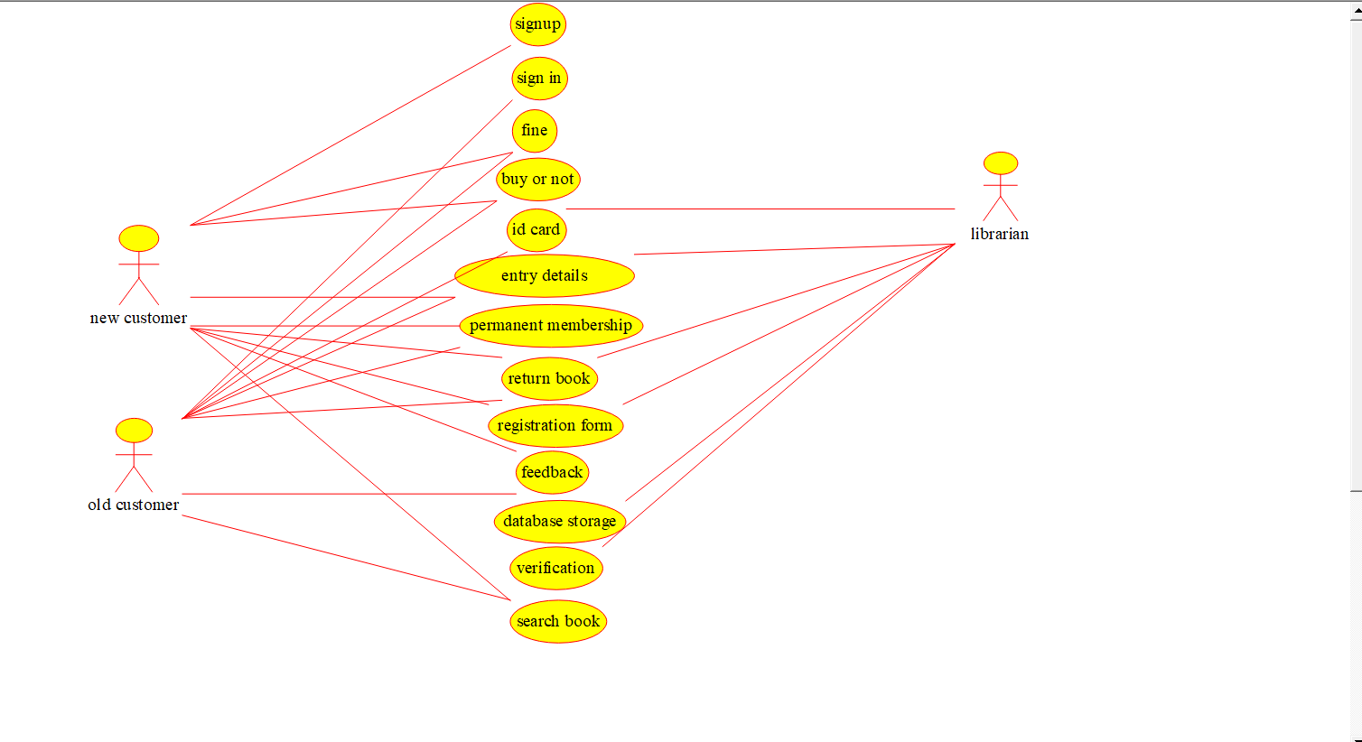

3Q. Draw and validate the flowchart to compute the quotient and remainder.

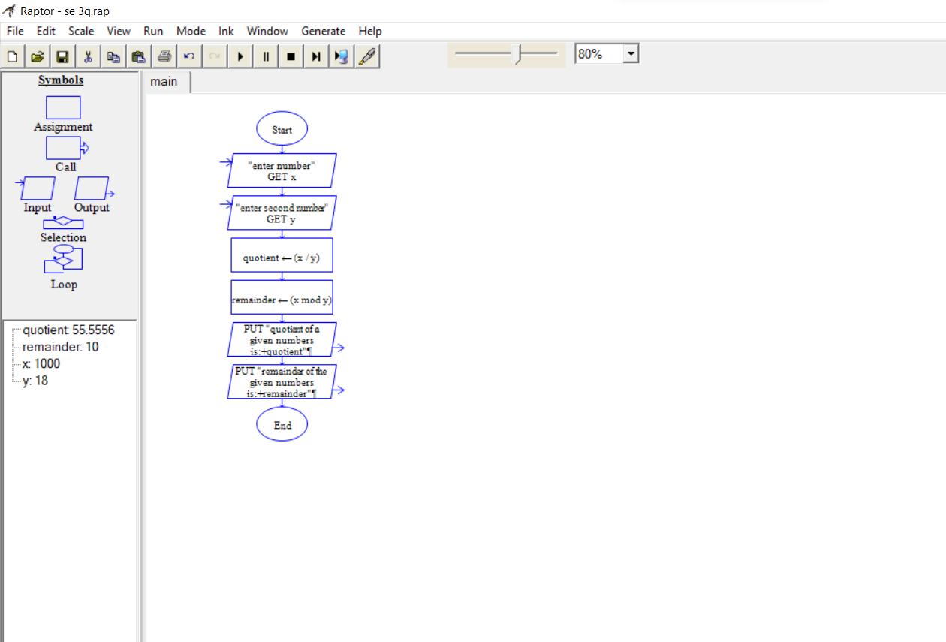

4Q. Draw a USE-CASE diagram for Online Shopping system using CASE tools.

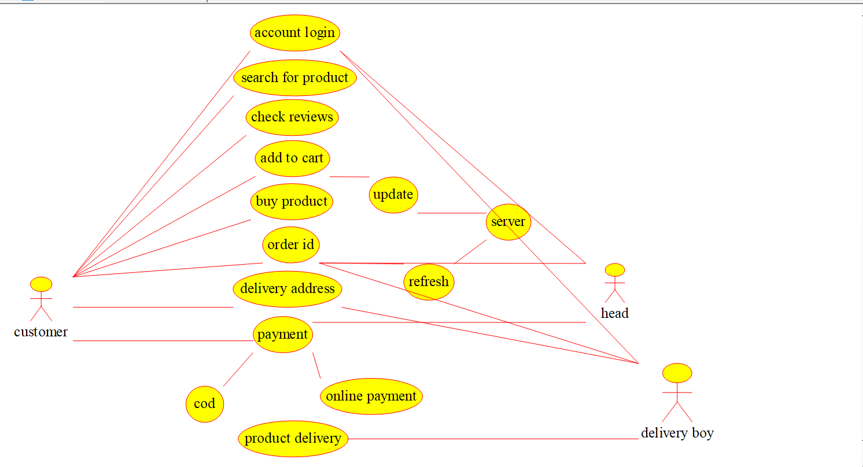

5Q. Draw a USE-CASE diagram for Online Railway Reservation System using CASE tools**.**

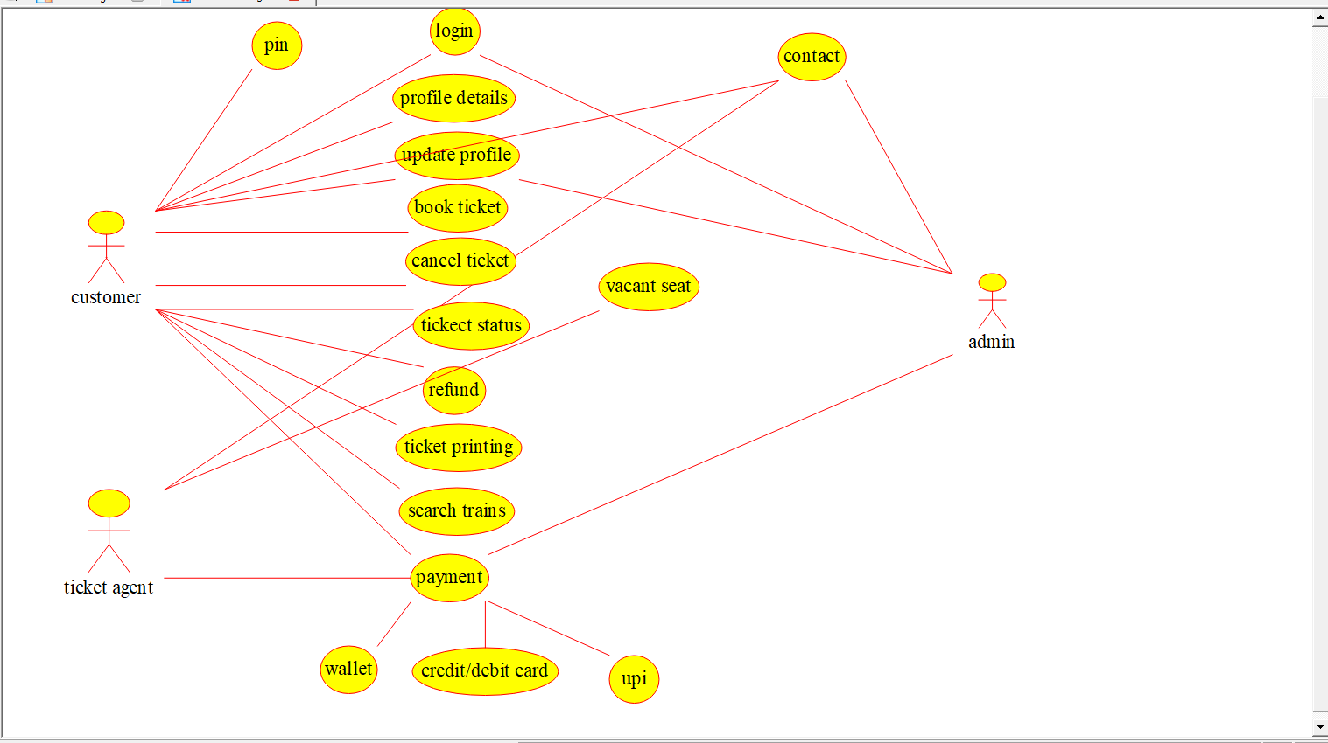

6Q. Draw a USE-CASE diagram for Hospital Management System using CASE tools.

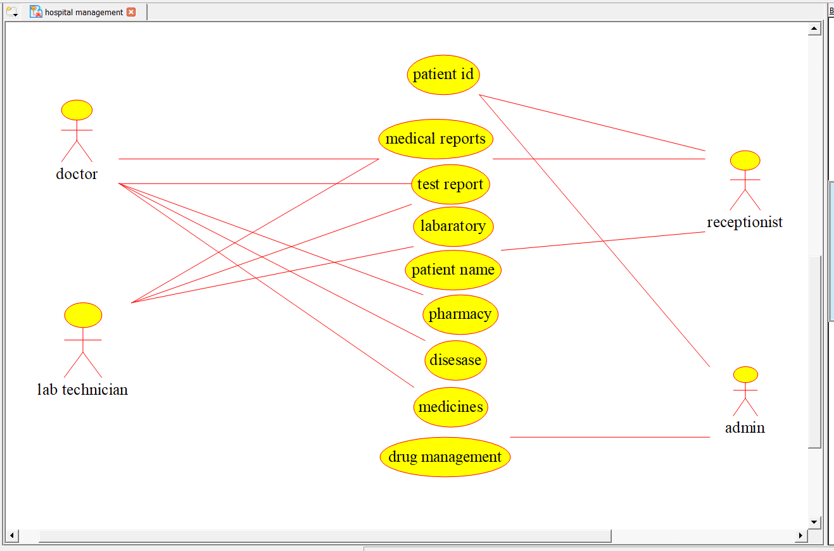

7Q. Draw a USE-CASE diagram for ATM System using CASE tools.

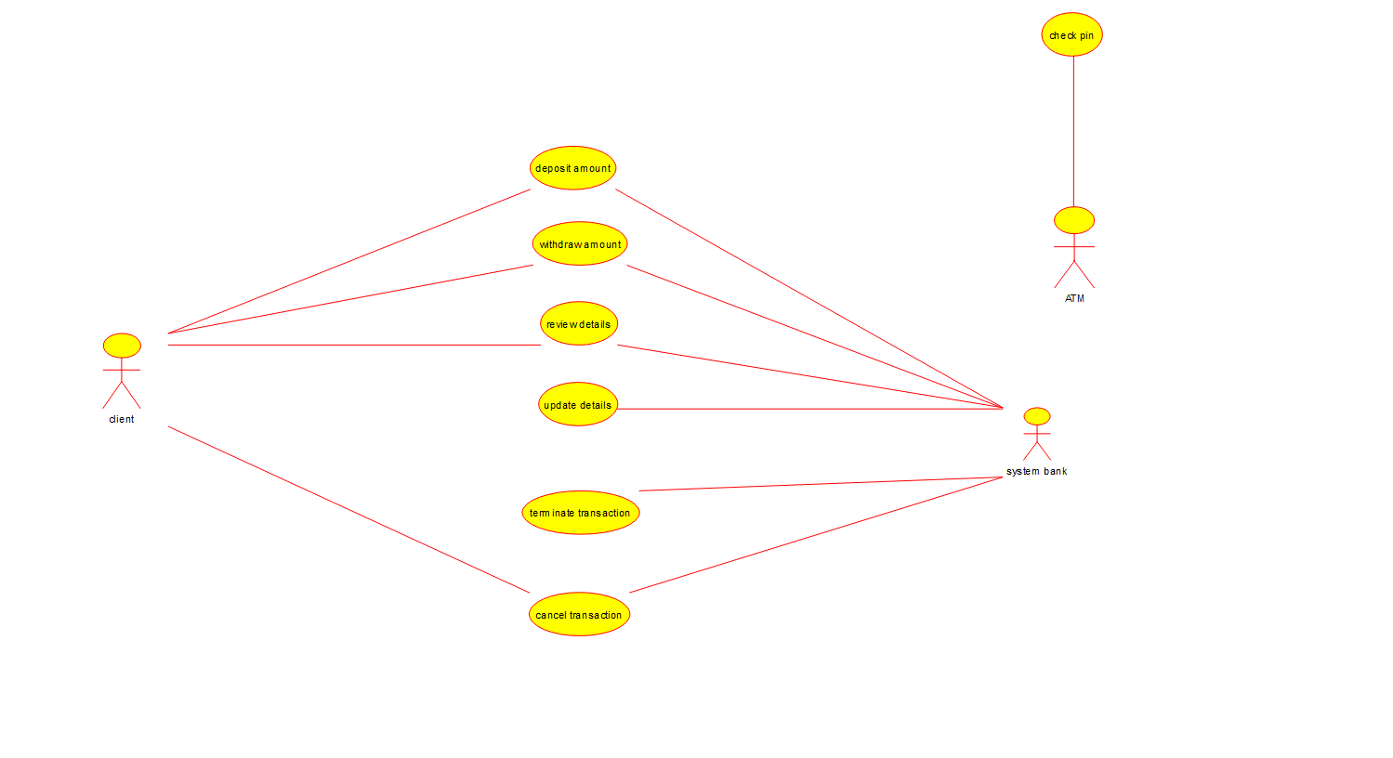

8Q. Draw a USE-CASE diagram for Online college management System using CASE tools**.**

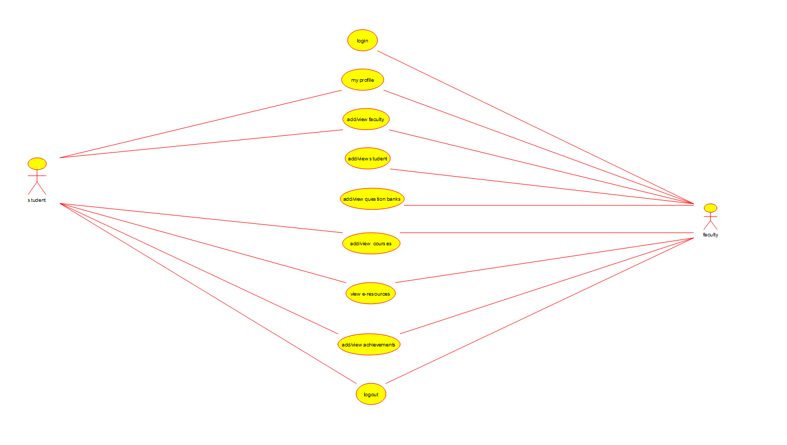

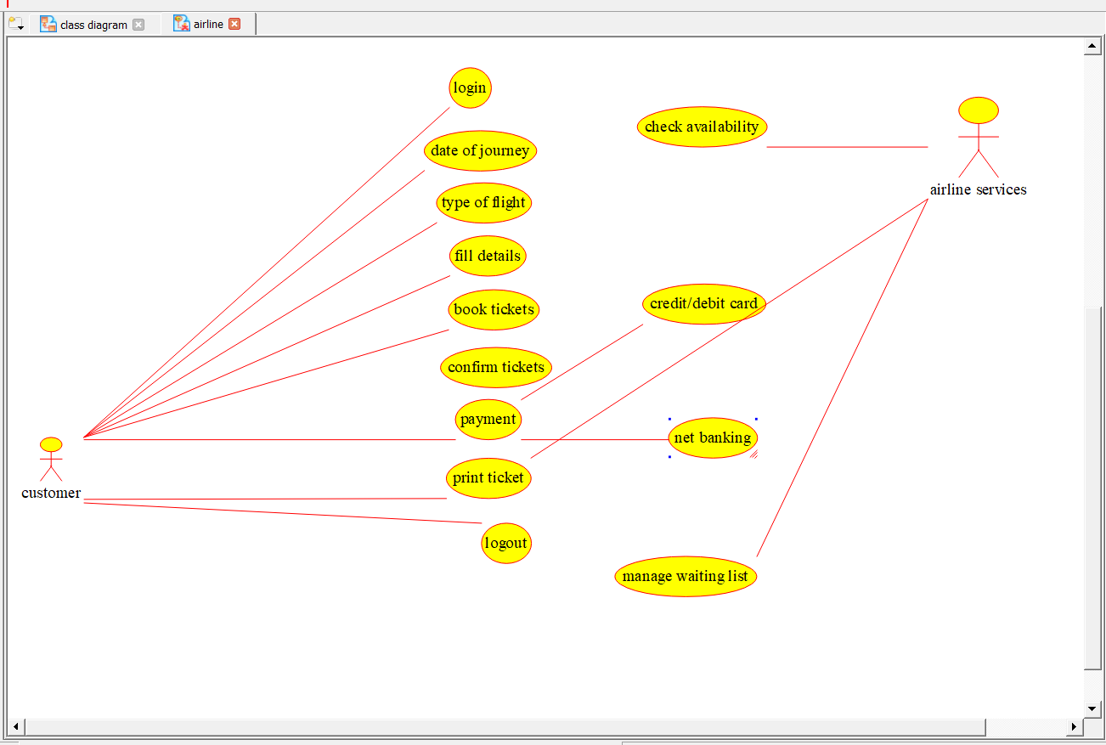9Q. Draw a USE-CASE diagram for Online Airline Reservation System using CASE tools.

10Q. Draw a Class diagram for Online Airline Reservation System using CASE tools**.**

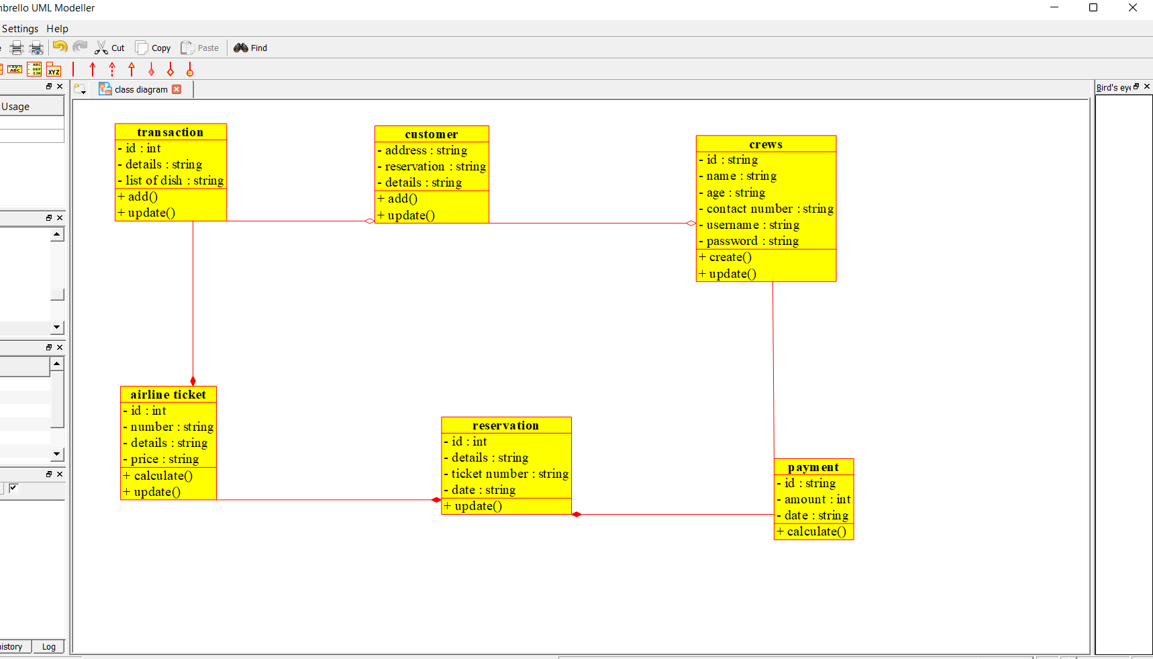

11Q. Draw a Class diagram for Online Voting System using CASE tools

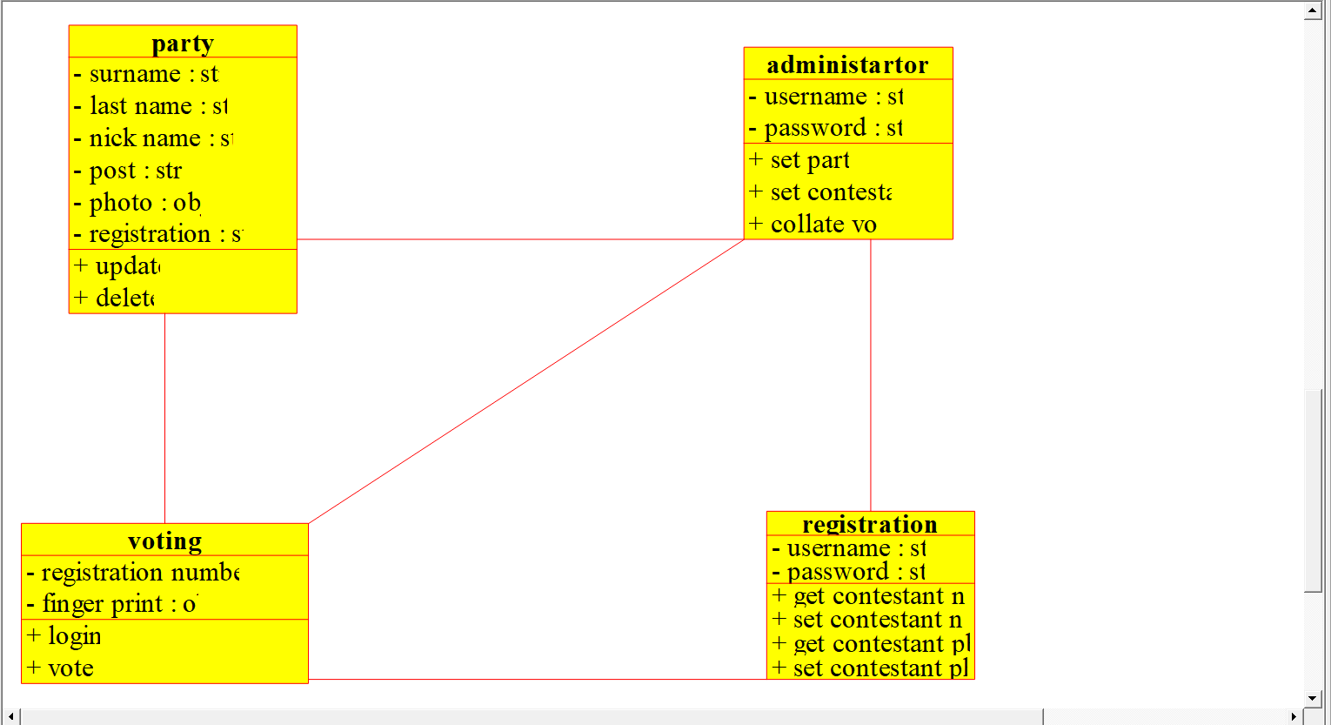

12Q. Draw a Class diagram for Library Management System using CASE tools.

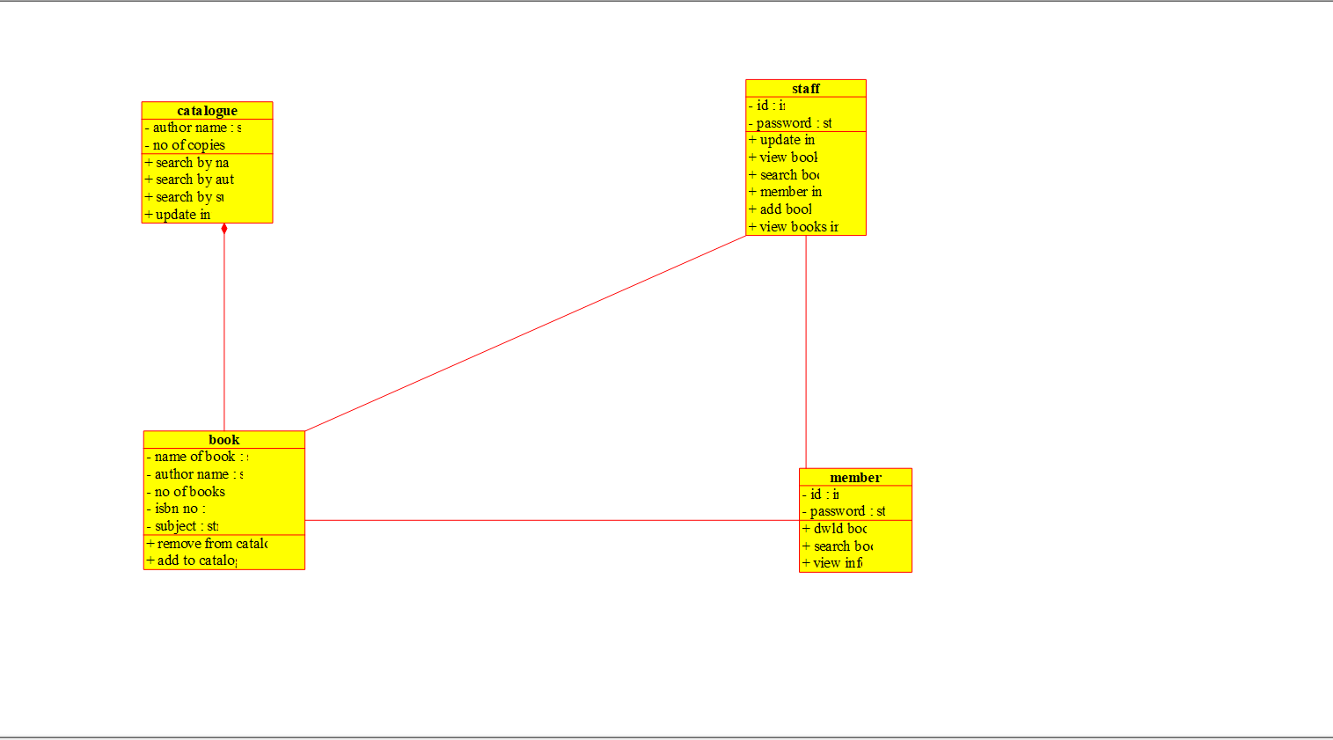

13Q. Draw a Activity diagram for Online Voting System using CASE tools.

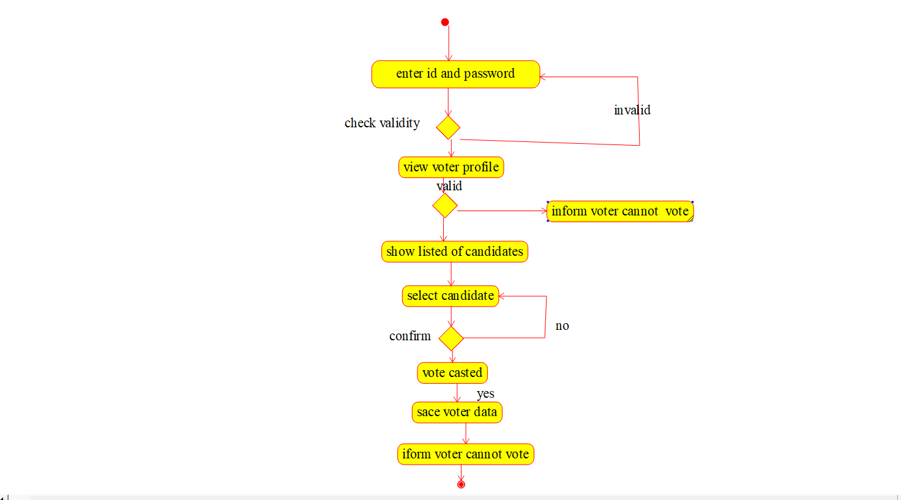

14Q. Draw a Activity diagram for Library Management System using CASE tools.

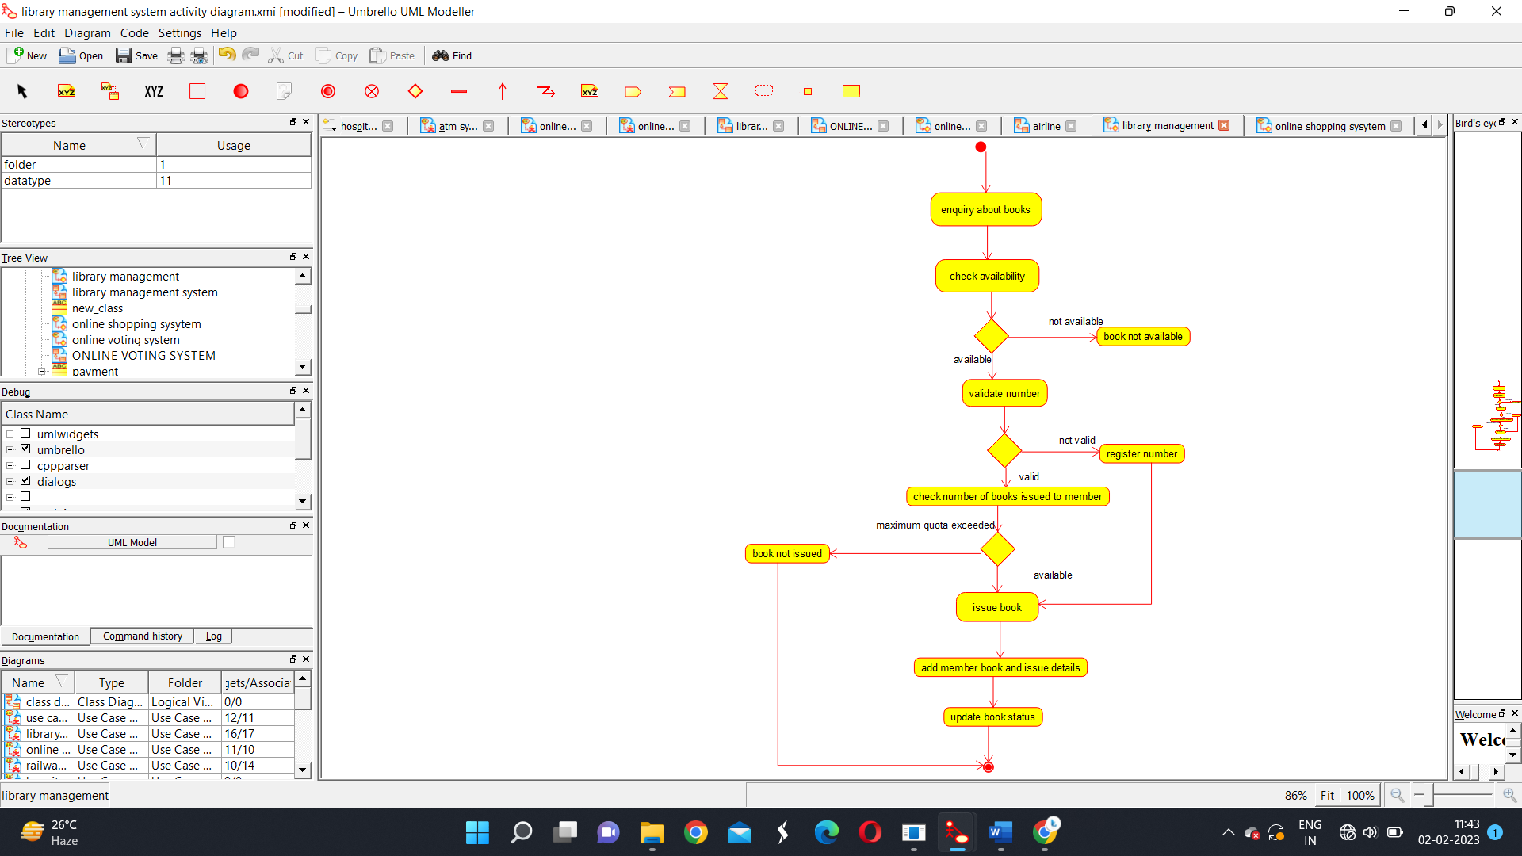

15Q. Draw a Activity diagram for Online Shopping system using CASE tools.

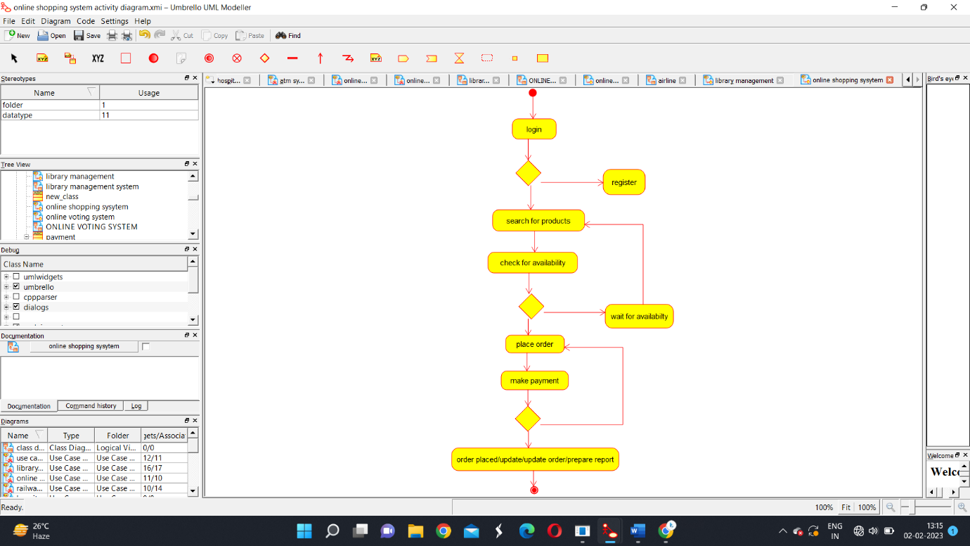

16Q. Draw a Activity diagram for Online Railway Reservation System using CASE tools.

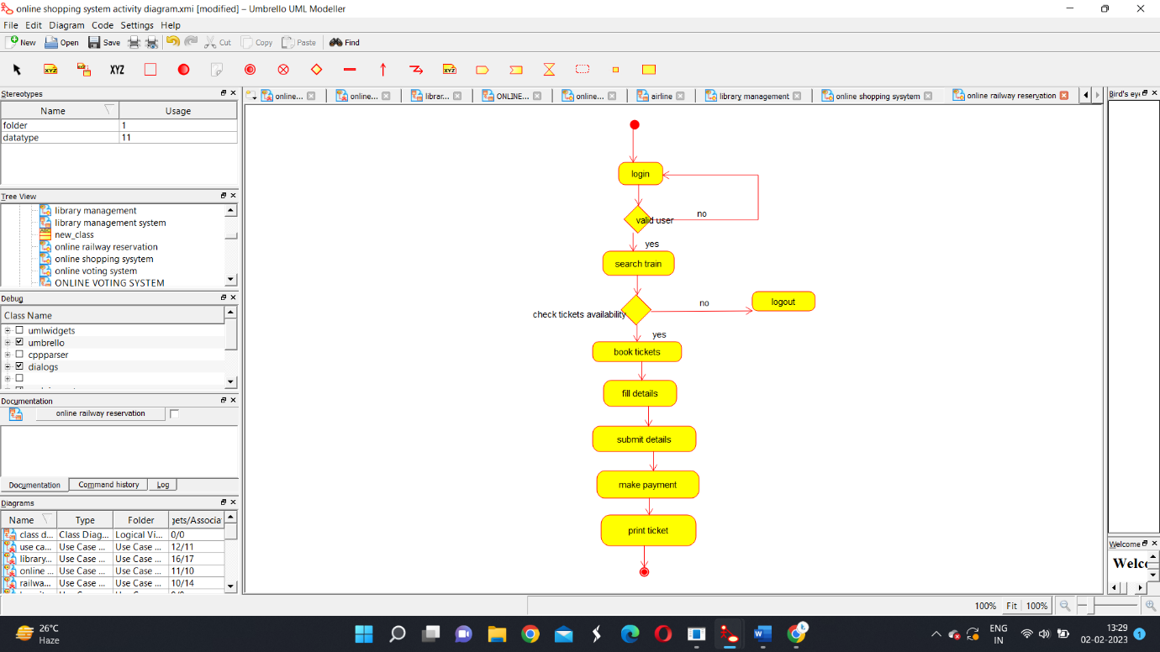

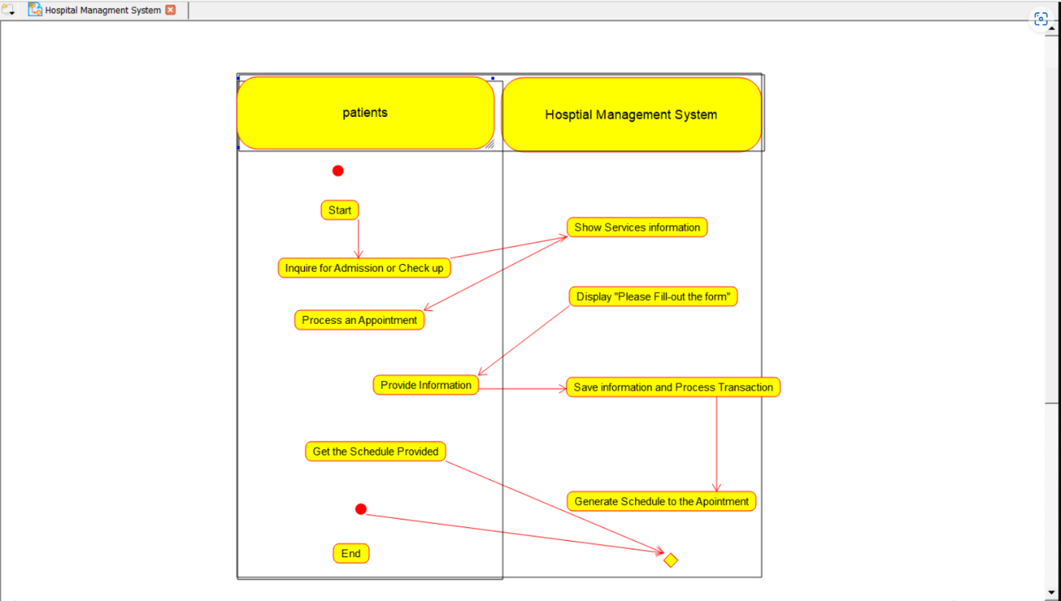17Q. Draw a Activity diagram for Hospital Management System using CASE tools.

18Q. Using Raptor- Draw the flowchart to check whether the given number is a palindrome or not.

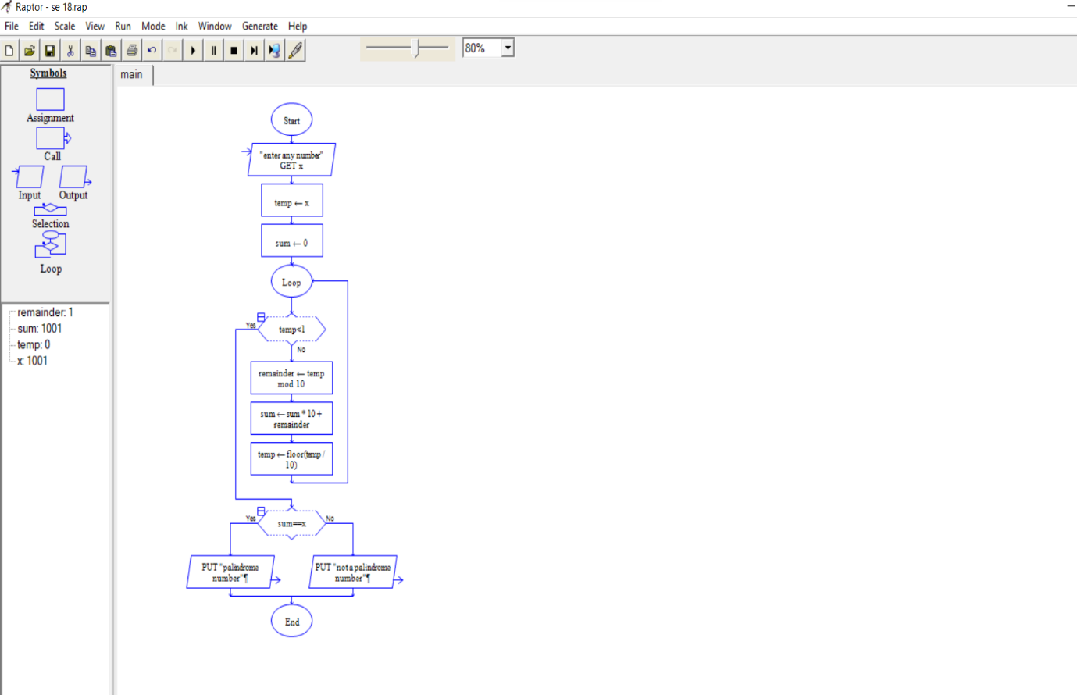

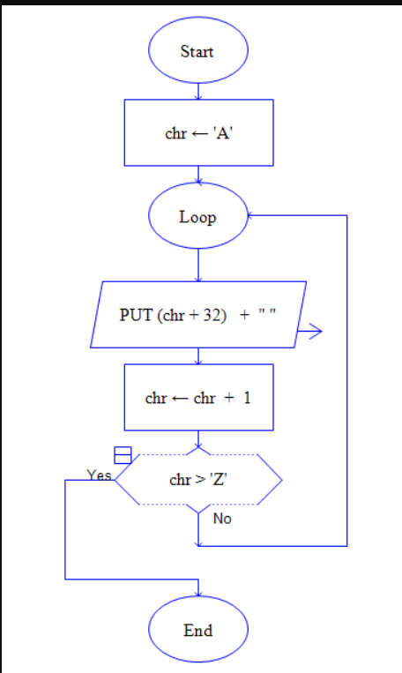19.Using Raptor – Draw the flowchart to convert lower case letters to upper case letters

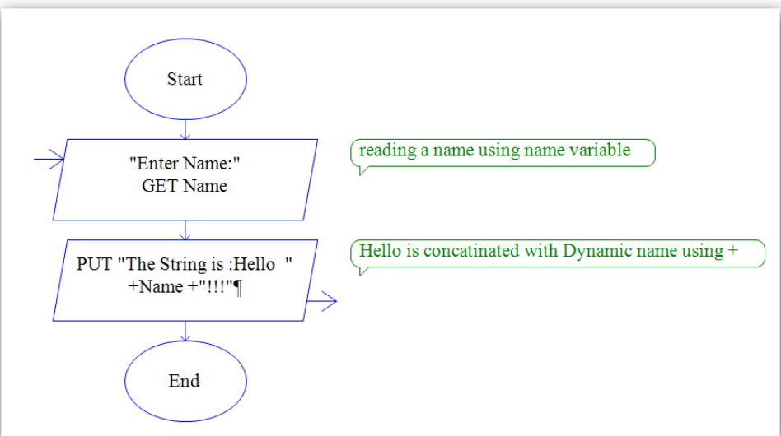20.Using Raptor – Draw the flowchart to count total number of strings in a given word

**24Q. Using Raptor - Draw the flowchart to find whether the given number is prime or not.**

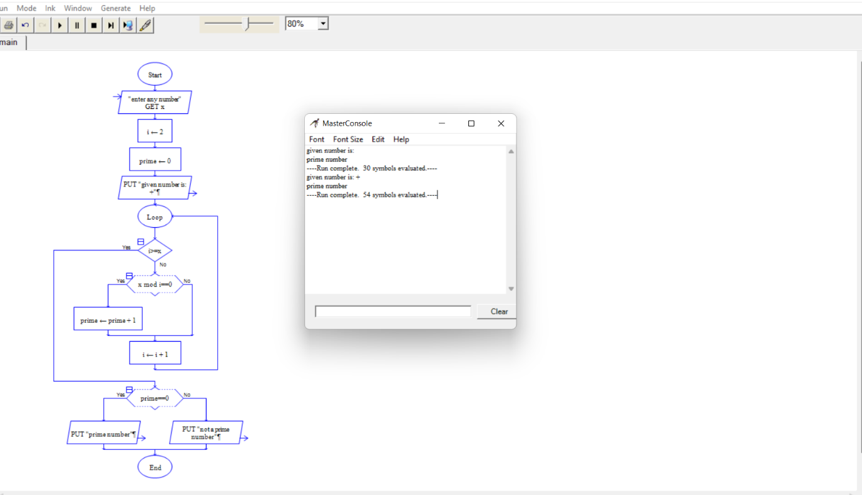21Q. Using Raptor - Draw the flowchart to find whether the given number is prime or not.

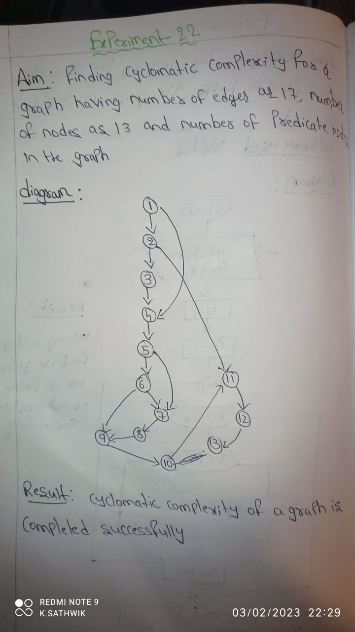22Q. Find Cyclomatic Complexity for a graph having number of edges as 17, number of nodes as 13 and number of predicate nodes in the flow graph as 5.

23.Design an activity diagram for an automated online banking system which shows the flow of withdrawal, deposit and balance enquiry**.**

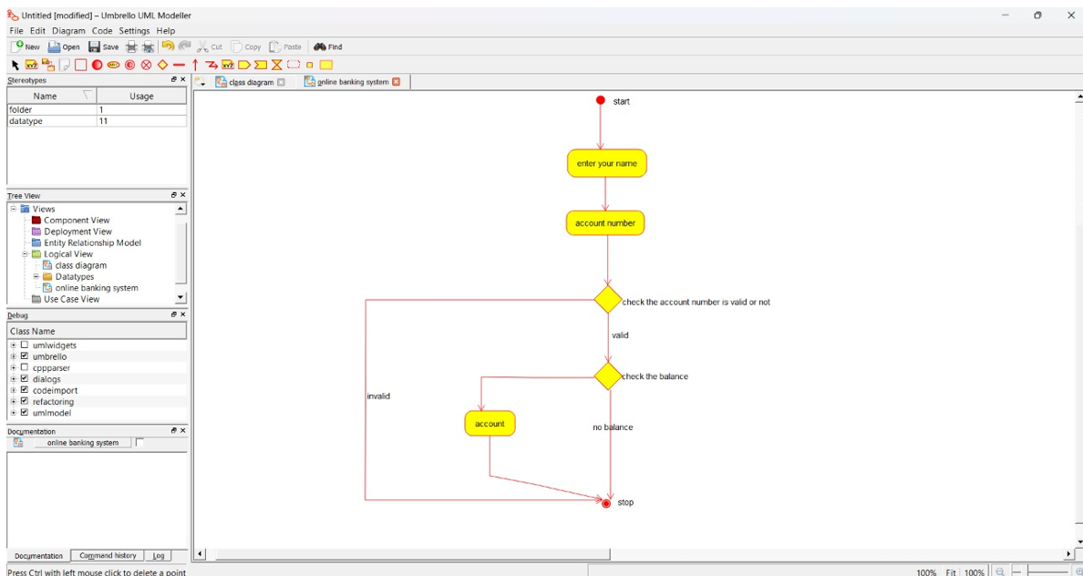

24.Develop an activity diagram for an e-library online public access catalogue

25.Draw a Class diagram for an e-library online public access catalogue

26.Draw a Use Case diagram for a Restaurant Systems

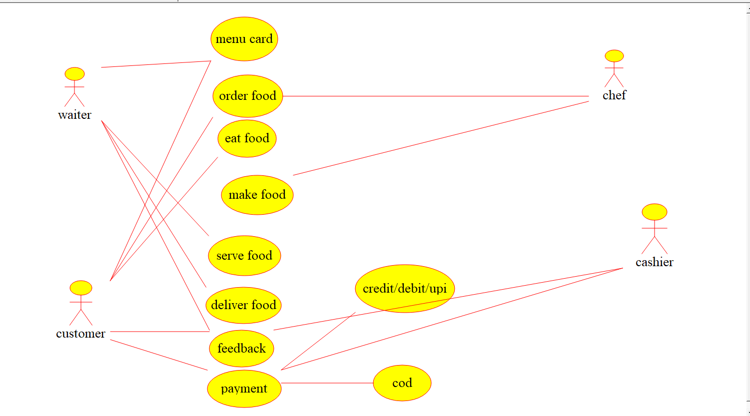

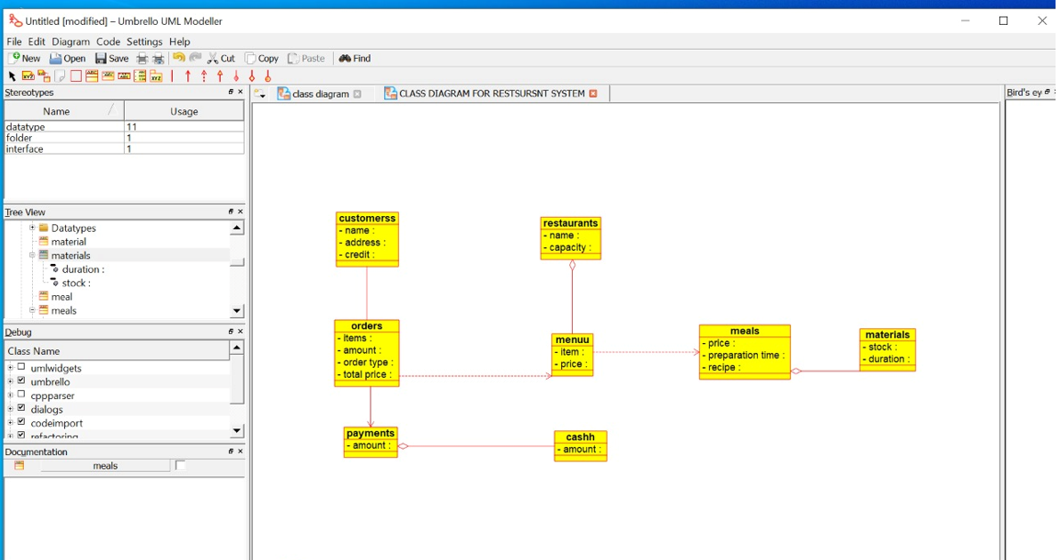27.Draw a Class diagram for a Restaurant Systems

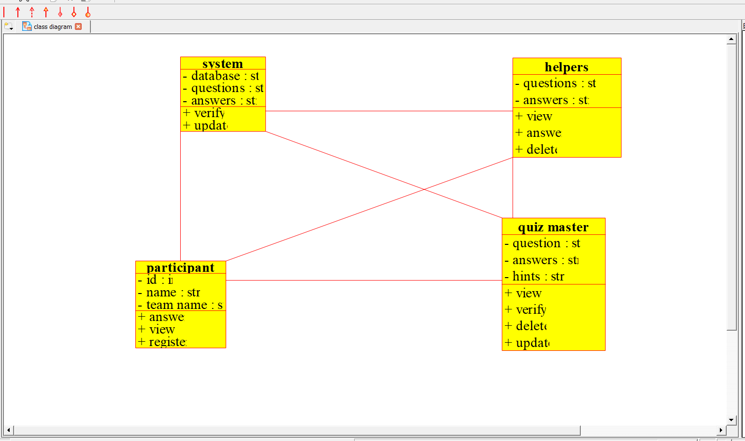28.Make a class diagram to model for a quiz system

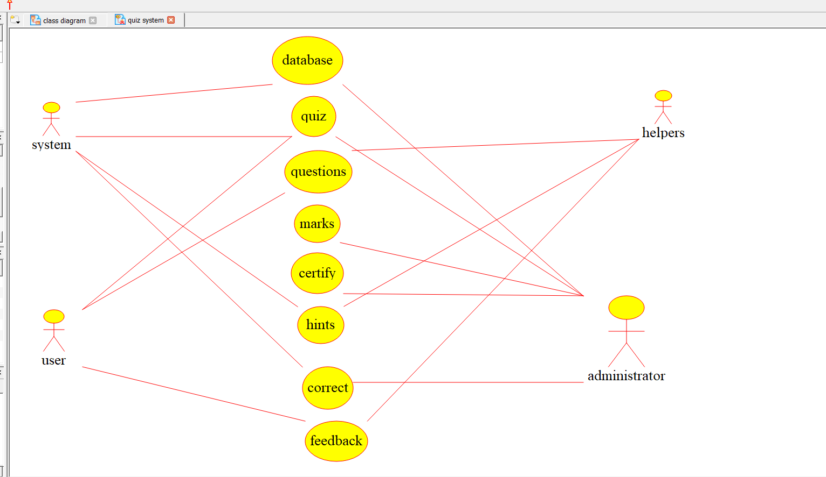29. Draw a Use case diagram to model for a quiz system

30.Using Raptor- Draw and validate the flowchart to calculate Factorial of a number.

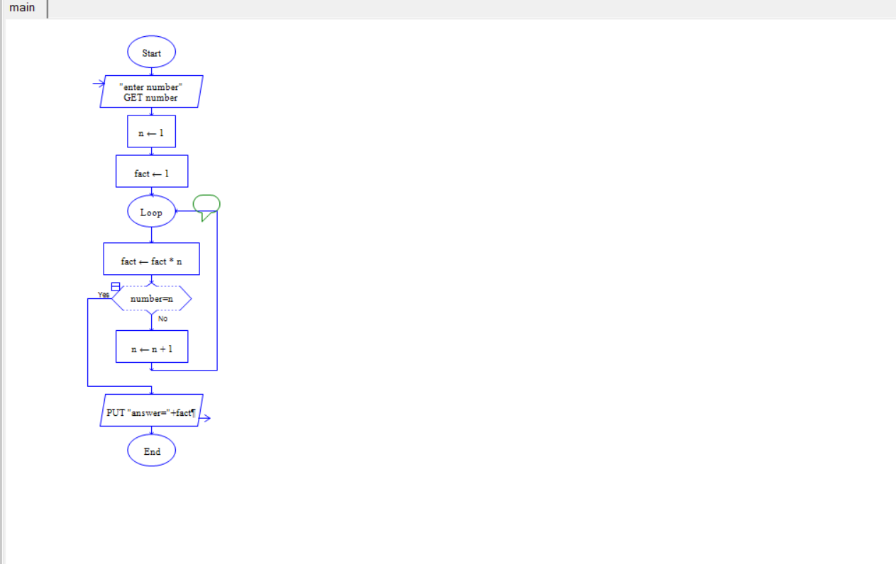

31.Using Raptor – Draw and validate the flowchart to find odd series of the given number and even series up to a given number

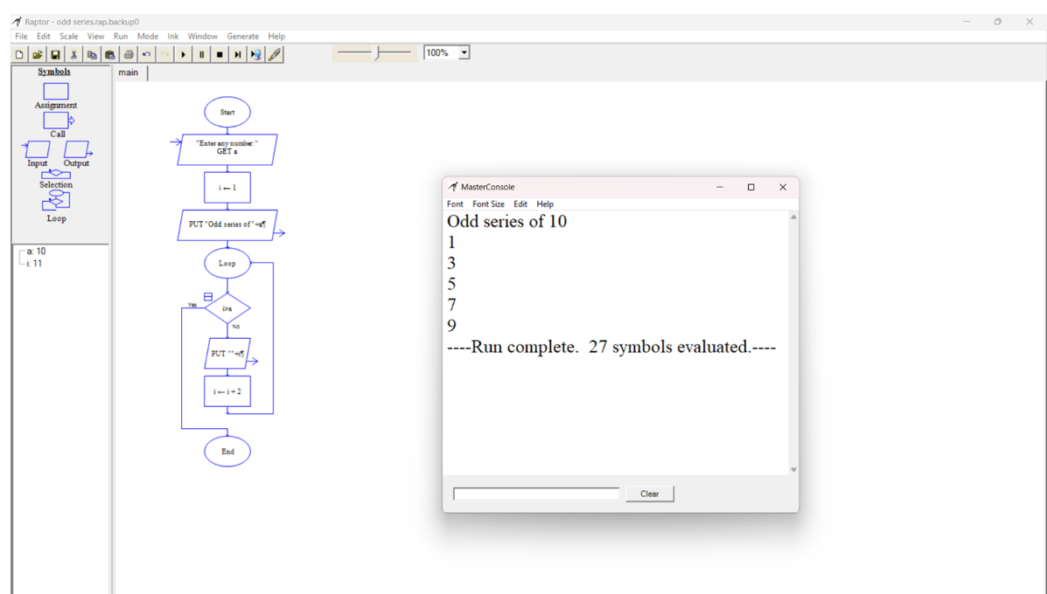

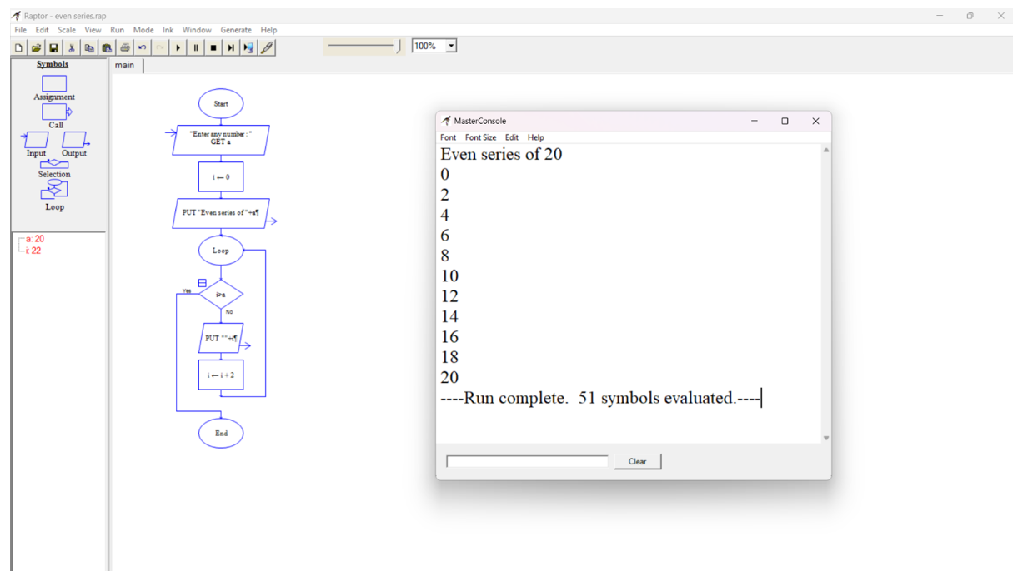

32. Using Raptor – Draw the flowchart to display the reverse of the string.

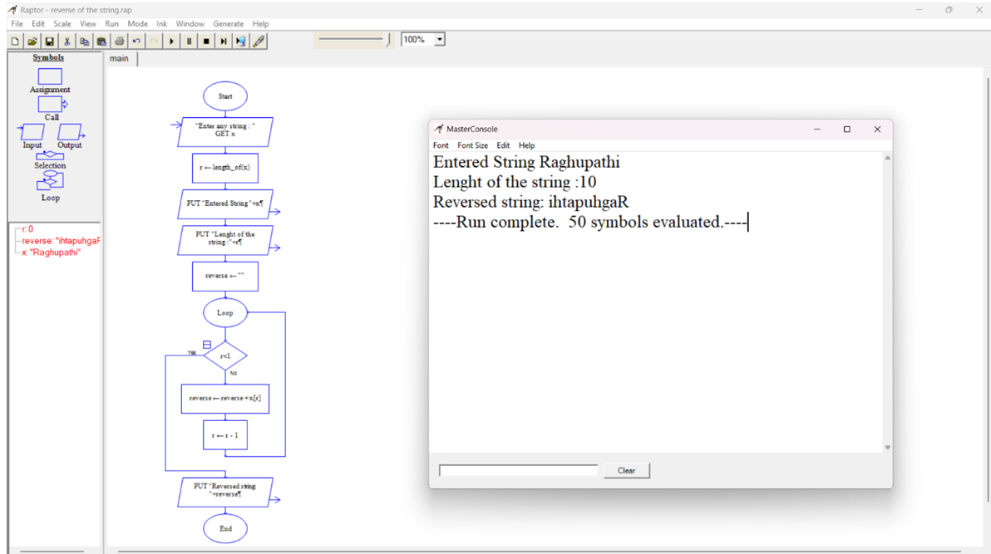

1. Using Raptor – Draw the flowchart to find sum of n numbers.

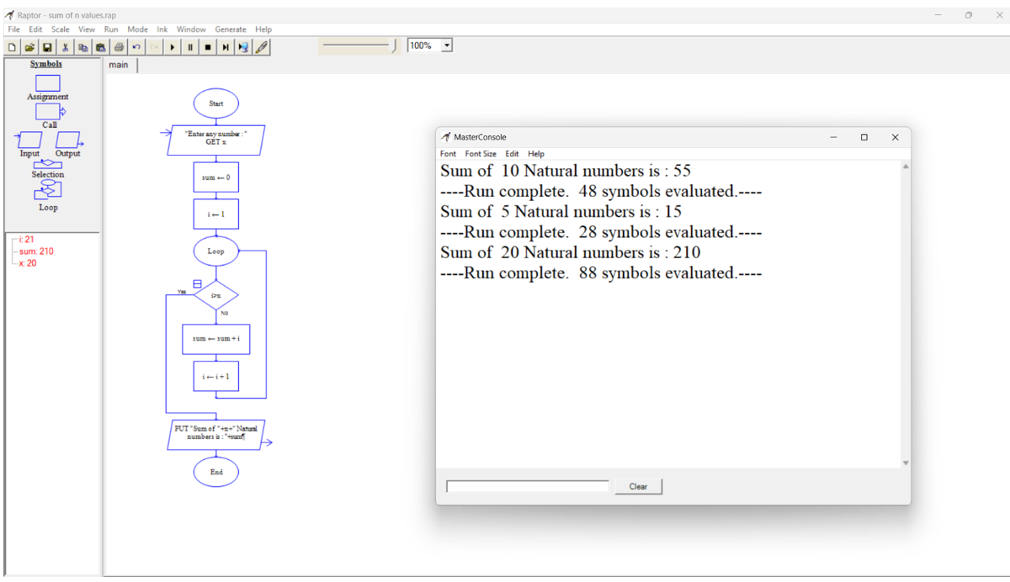

1. Using Raptor – Draw the flowchart to find largest of n numbers.

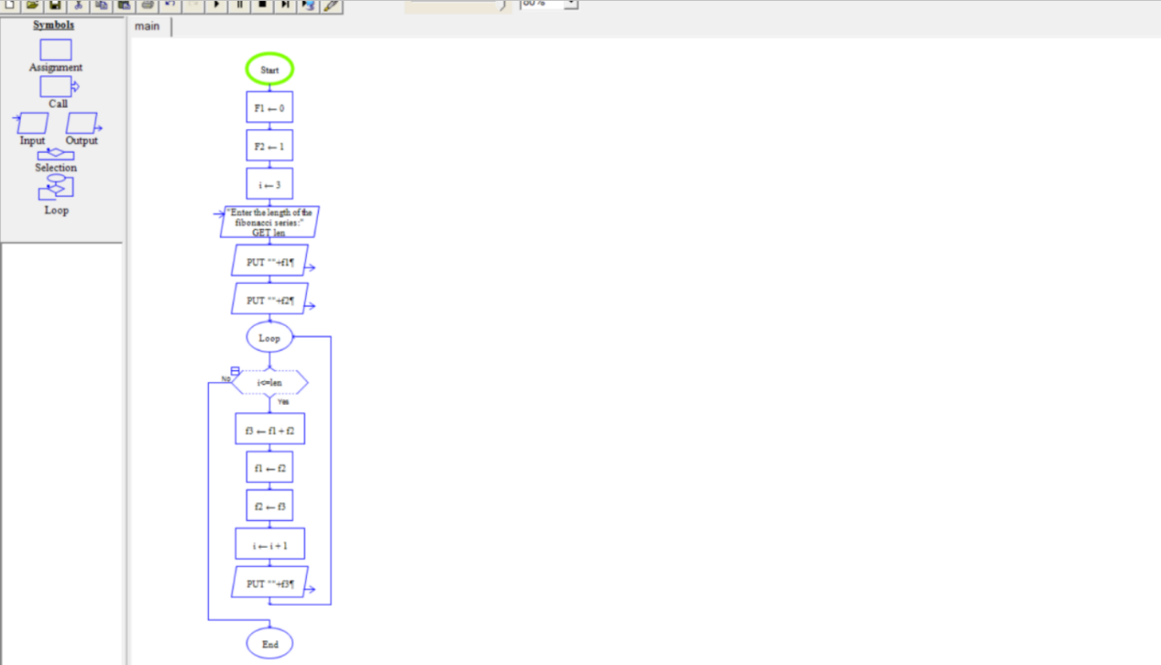

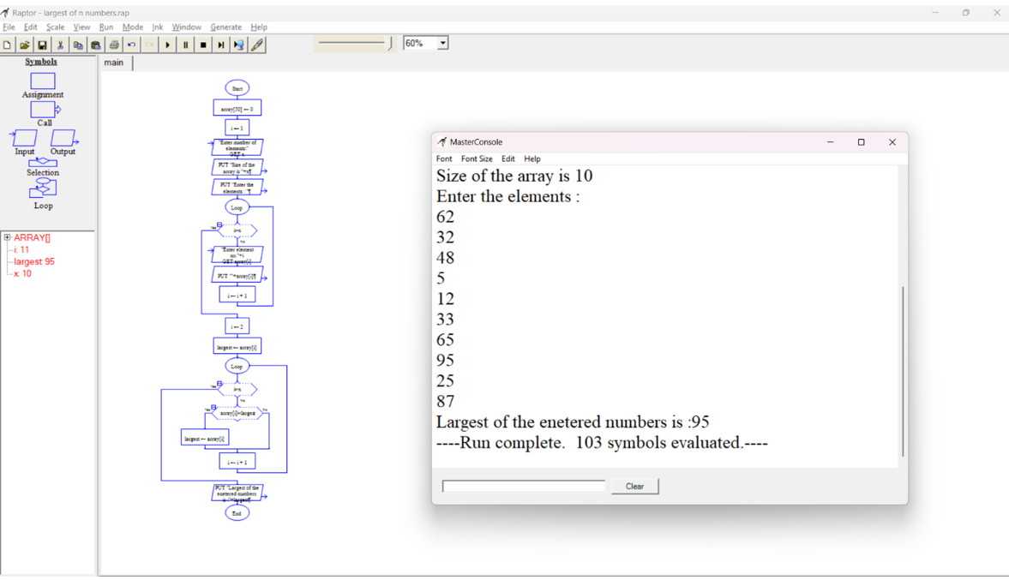

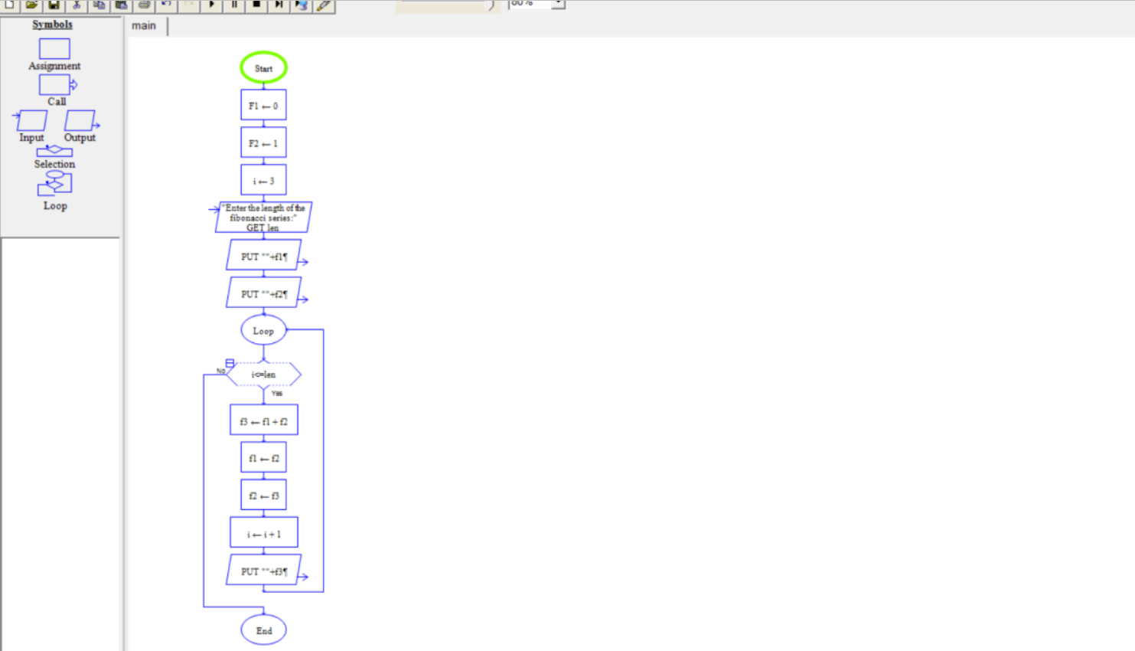35 Q. Using Raptor- Draw and validate the flowchart to calculate Fibonacci series.

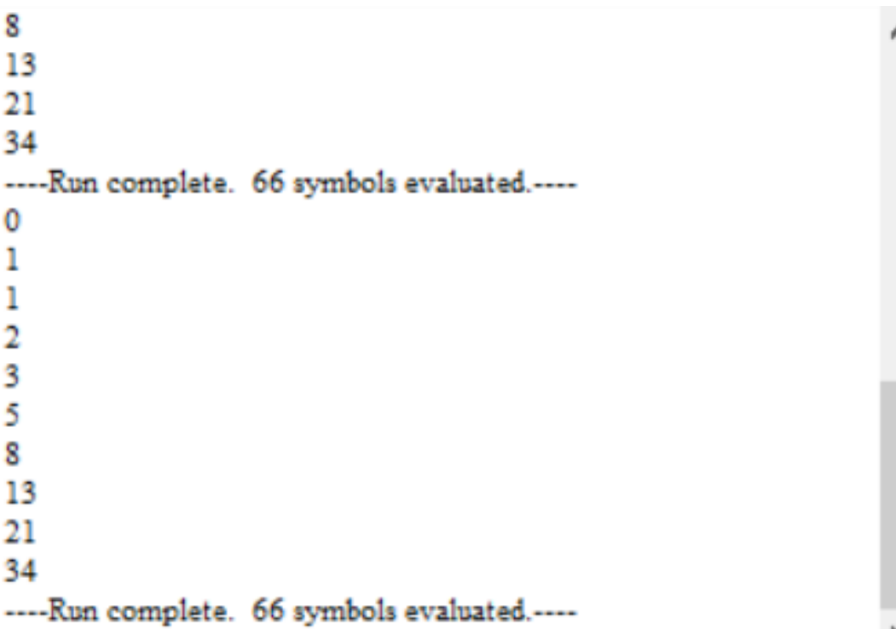

36. Using Raptor – Draw the flowchart to find smallest of n numbers

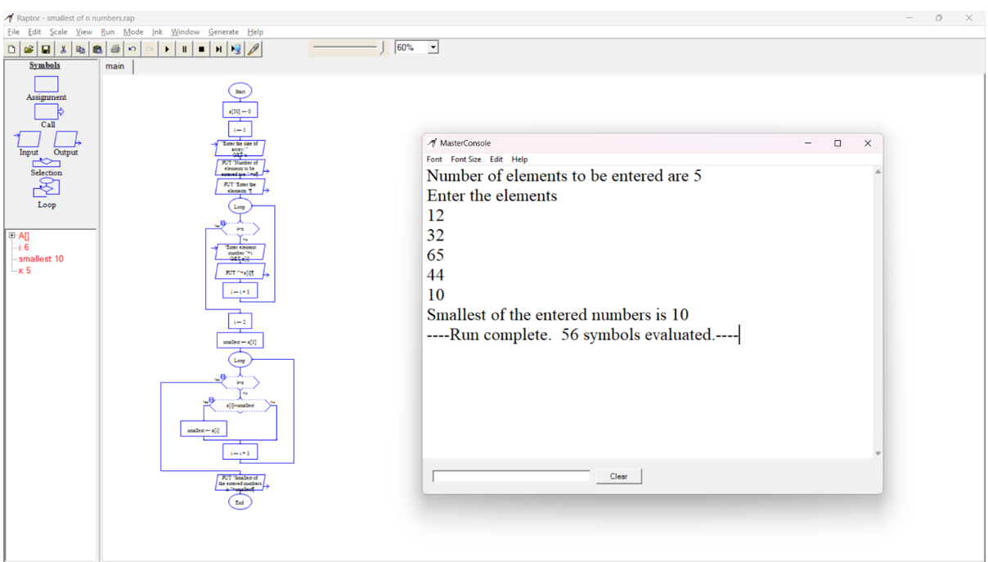

37. E Wallet Management System (EMS) using Use case diagram

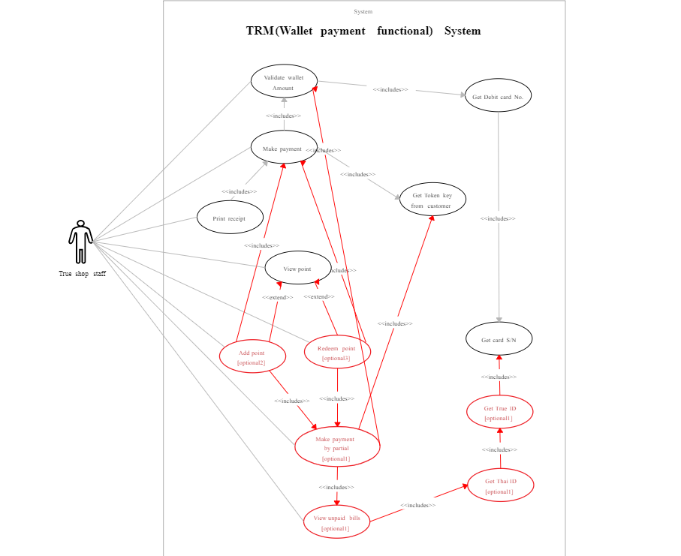

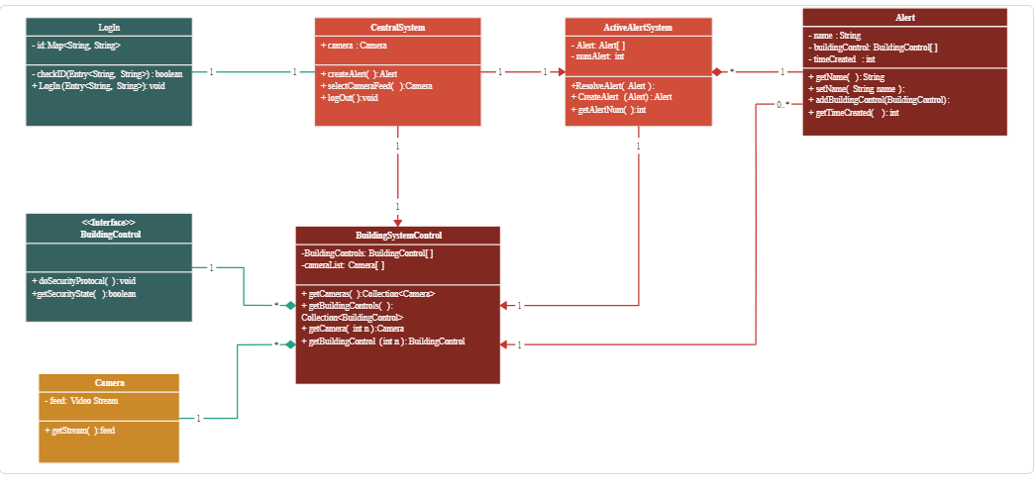38. Online security management system using class diagram

****39.use case diagram for online voting

40. Construct a flowchart using raptor and Check whether a string is palindrome or not

